Kazakh-British Technical University
Data Mining: Final Report

“Diabetes 130-US Hospitals for Years 1999-2008”

Tsoy Yuliya, Bazargalieva Fatima, Suleimenova Amina

CONTENTS

1 Introduction 3
1.1 Dataset Description 3
1.2 Problem Statement 3
1.3 Hypotheses 3
2 Dataset work 4
2.1 Data cleaning 4
2.2 Data Transformation 4
2.3 Target Variable and Class Distribution 4
3 Exploratory Data Analysis (EDA) 5
3.1 Summary statistics For numerical variables, the following summary statistics were computed: 5
3.2 Correlation Analysis (Heatmap) 7
3.3 Scatter plot 8
3.4 Histogram 10
3.5 Insights 11
4 Data Mining Techniques 11
4.1 Algorithms 11
4.2 Model Evaluation & Comparison 11
4.3 Cross-Validation Strategy 12
4.4 Hyperparameter Tuning 13
5 Results 13
5.1 Evaluation Metrics and Model Performance 14
5.2 Baseline vs Improved Models 14
5.3 Model Performance Visualization 15
5.4 Hypothesis check 17
6 Conclusion 18
6.1 Advantages and Disadvantages of the Algorithms 18
6.2 Model Justification 18
6.3 Future Work 18

1 Introduction

1.1 Dataset Description
This project is based on the “Diabetes 130-US Hospitals (1999–2008)” dataset obtained from the UCI Machine Learning Repository.
The dataset contains information on more than 100,000 hospital encounters of diabetic patients collected from 130 hospitals across the United States over a ten-year period (1999–2008).
Each record represents a single hospital admission and includes:
- patient demographic information (age group, gender, race),
- clinical variables (diagnoses, laboratory tests),
- treatment-related features (medications, procedures),
- administrative attributes (admission type, discharge disposition),
- readmission outcome.
The dataset consists of over 50 features and has a tabular structure, combining both categorical and numerical variables, making it suitable for classical machine learning approaches.

1.2 Problem Statement
Diabetes is one of the most widespread chronic diseases, requiring long-term monitoring and frequent hospital readmissions. High readmission rates increase the workload on healthcare systems and raise overall treatment costs. Therefore, identifying the factors influencing patient readmission is crucial for improving care quality and optimizing hospital resources.

The task addressed in this study is a binary classification problem.
The objective is to predict whether a patient will be readmitted to the hospital within 30 days after discharge.

This prediction task is clinically important, as early identification of high-risk patients can help healthcare providers improve treatment planning, reduce readmission rates, and lower healthcare costs.

1.3 Hypotheses
To address the research objectives, the following hypotheses were formulated prior to the analysis and subsequently evaluated using exploratory data analysis and predictive modeling techniques.
Hypothesis 1 (H1): Demographic and Clinical Factors
Demographic and clinical patient characteristics, including age, length of hospital stay, and the number of prescribed medications, are associated with an increased risk of hospital readmission within 30 days.
Hypothesis 2 (H2): Hospital Stay Duration and Treatment Intensity
The likelihood of hospital readmission is dependent on the duration of hospitalization and the intensity of treatment, as reflected by the number of medications administered and laboratory procedures performed.
Hypothesis 3 (H3): Predictive Model Feasibility
A predictive model can be developed using the available hospitalization data to estimate the probability of patient readmission within 30 days.

2 Dataset work

2.1 Data cleaning
A systematic data cleaning procedure was applied to ensure data quality and analytical reliability. This included all "?" symbols were replaced with NaN values, and missing data were examined across all variables. Records with invalid gender values ("Unknown/Invalid") were removed. The weight feature was excluded due to a high proportion of missing values (over 40%). Missing values in the medical_specialty attribute were imputed using the "Unknown" category. After completing the cleaning process, the dataset index was reset.

As a result, the dataset size changed from 101,766 rows and 50 columns to 101,763 rows and 49 columns.

2.2 Data Transformation
Following cleaning, the dataset underwent several transformation steps to prepare it for machine learning analysis. Categorical variables were encoded into numerical representations suitable for modeling, while numerical features were scaled where required to ensure algorithmic stability. Feature selection was performed to exclude irrelevant or redundant variables, and the target variable was redefined to focus specifically on readmission within 30 days, resulting in a binary classification task.

2.3 Target Variable and Class Distribution

For the classification task, the target variable was defined as hospital readmission within 30 days after discharge (<30). All other outcomes were treated as non-readmission cases for the purposes of binary classification, where:
• 0 - the patient will NOT be readmitted within 30 days
• 1 - the patient WILL be readmitted (<30)
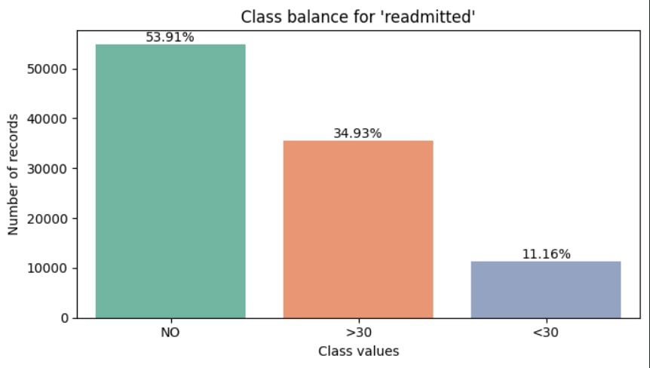
An analysis of the target variable distribution revealed a class imbalance, with readmissions within 30 days occurring significantly less frequently than non-readmission cases. This imbalance reflects real-world clinical patterns but introduces additional challenges for predictive modeling, particularly in terms of detecting minority class instances.

The presence of class imbalance was explicitly considered in the subsequent modeling and evaluation stages, motivating the use of appropriate performance metrics and validation strategies.

3 Exploratory Data Analysis (EDA)

Exploratory Data Analysis was conducted to understand the structure, distribution, and quality of the data. Comprehensive descriptive statistics were computed to examine central tendency, dispersion, and distributional characteristics of numerical variables. These statistics provided an initial understanding of hospitalization patterns and treatment intensity across patient groups.

3.1 Summary statistics
For numerical variables, the following summary statistics were computed:
- mean,
- variance,
- standard deviation,
- minimum and maximum values,
- percentage of missing values.
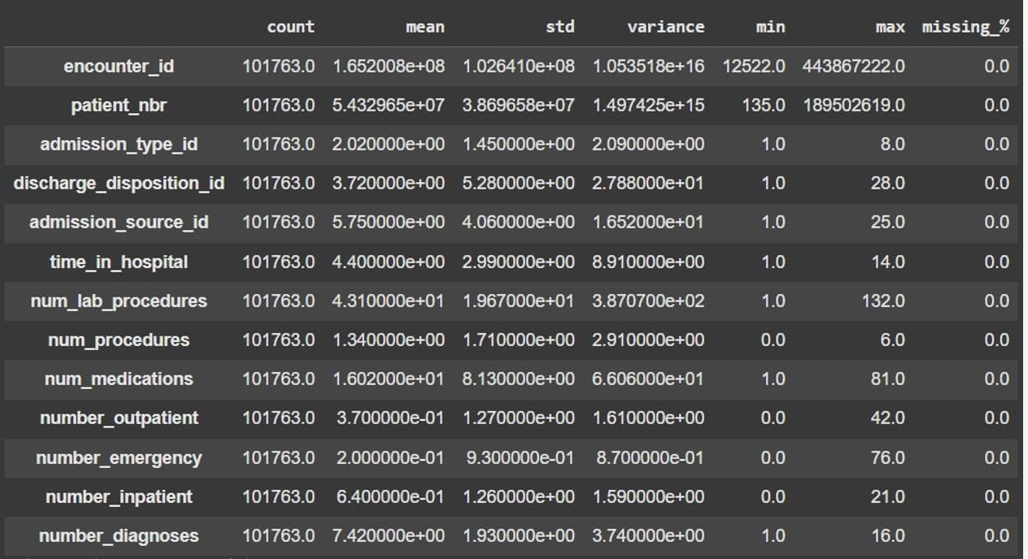
Importantly, the summary statistics show that the core numerical variables do not contain missing values, confirming a high level of data completeness and reliability for subsequent modeling. Variables related to hospital utilization, including the number of inpatient, outpatient, and emergency visits, are highly concentrated around low values, with a small proportion of patients accounting for extreme values. This suggests the presence of a subgroup of high-risk patients with frequent healthcare utilization.
Histogram analysis demonstrates that the length of hospital stay tends to increase with patient age, particularly among older age groups. In addition, longer hospital stays are positively associated with a higher number of prescribed medications, reflecting increased treatment complexity and disease severity. These patterns are consistent with clinical expectations, as older patients often present with multiple comorbidities and require more intensive management.
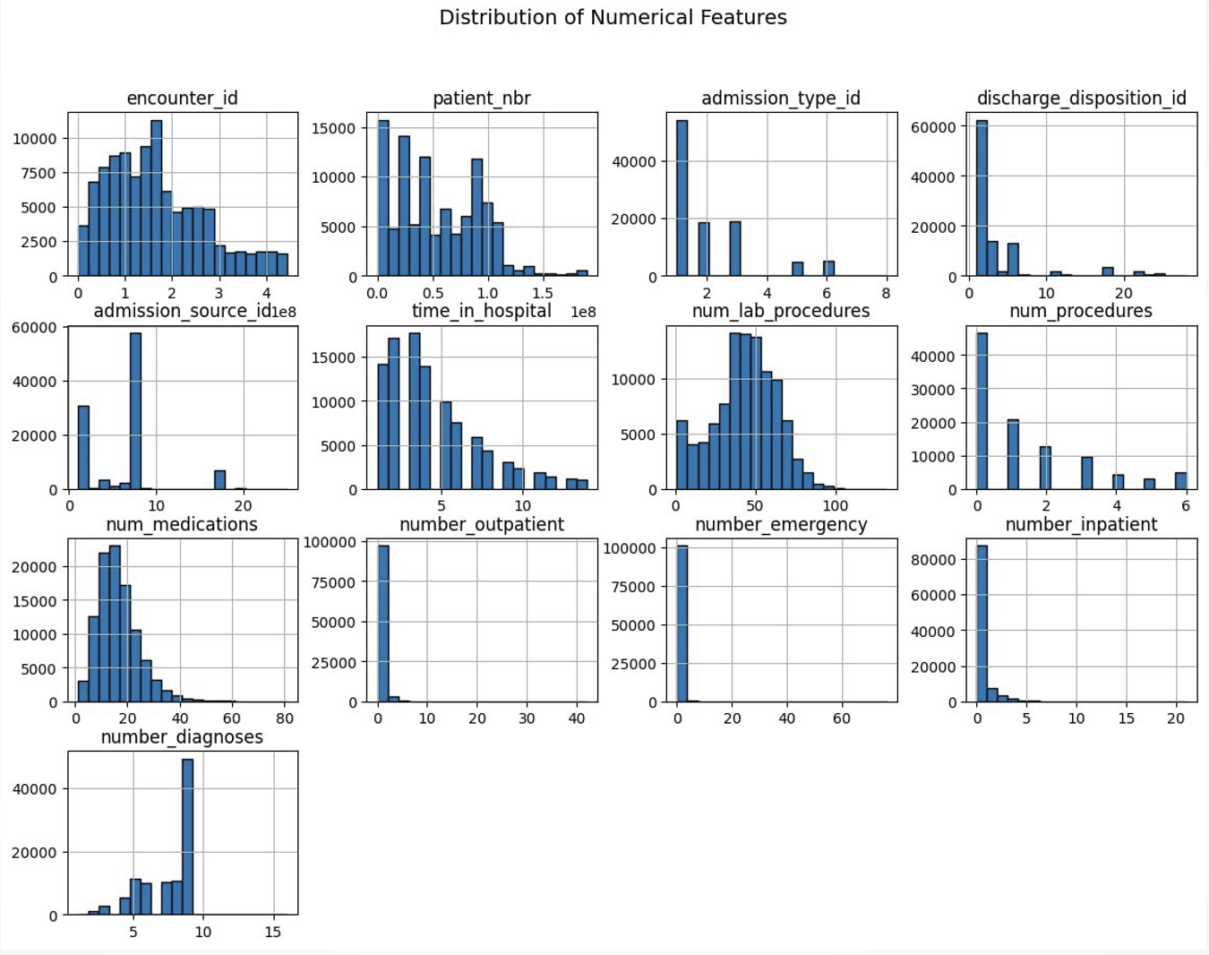

3.2 Correlation Analysis (Heatmap)
The correlation heatmap of numerical variables indicates the absence of strong linear relationships among the majority of features. Most correlation coefficients are close to zero, suggesting low multicollinearity within the dataset. This is an important result, as it implies that the selected variables capture different aspects of patient condition and hospital utilization rather than duplicating the same information. Consequently, the models are expected to estimate the individual contribution of each feature more reliably.
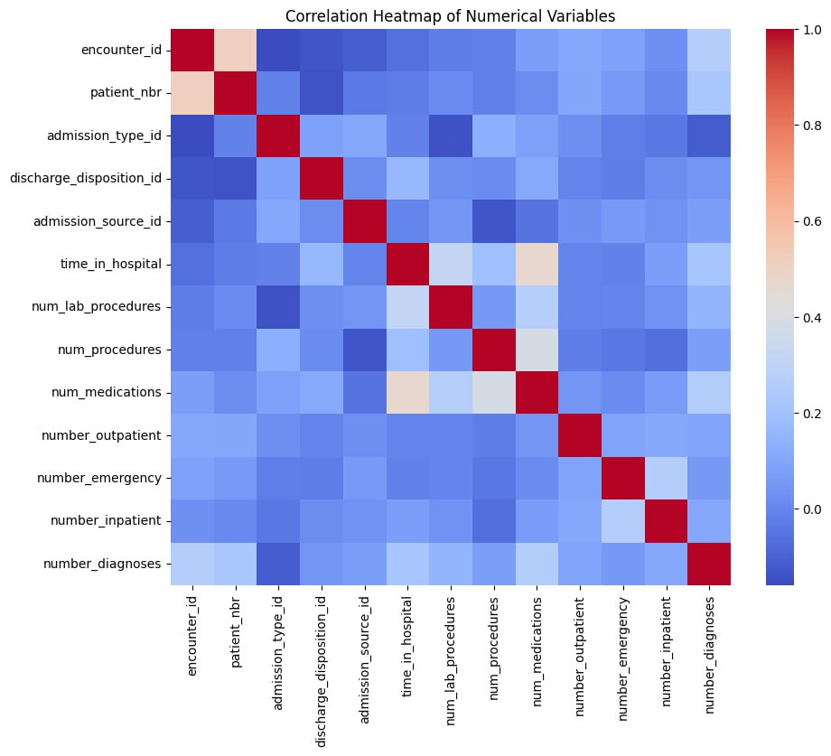
A weak but consistent positive correlation is observed between time in hospital and number of medications, as well as between number of laboratory procedures and number of medications. These relationships are clinically intuitive: patients who remain hospitalized for longer periods and undergo a higher number of diagnostic tests typically require more intensive pharmacological treatment.
Overall, the correlation structure supports the appropriateness of the selected feature set for predictive modeling. The lack of strong correlations reduces the risk of instability in coefficient estimation for linear models and enhances the interpretability of model outcomes.

3.3 Scatter plot
The scatter plots were used to visually examine the relationship between key clinical variables, specifically the length of hospital stay and the number of prescribed medications. The analysis reveals a weak but noticeable positive relationship between these variables: patients with longer hospitalization periods tend to receive a higher number of medications, reflecting increased treatment intensity in more severe or complex cases.
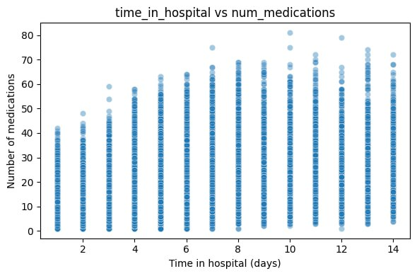

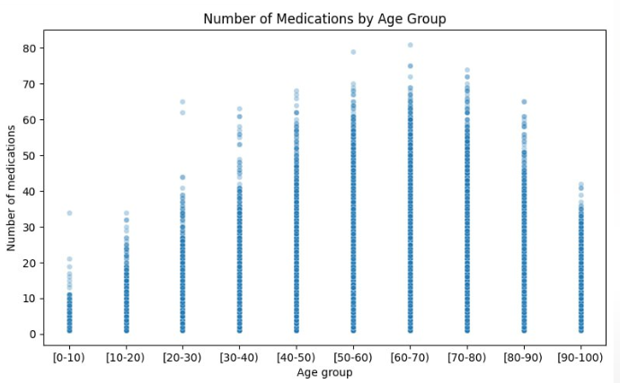
The distribution of observations is concentrated in the lower-left region of the plot, indicating that the majority of patients are hospitalized for 2–5 days and receive approximately 5–15 medications. A limited number of outliers can also be observed, corresponding to patients with extended hospital stays and a high number of prescribed medications, which likely represent severe or complicated cases.
Although the relationship is not strictly linear and exhibits substantial dispersion, the overall trend suggests that prolonged hospitalization is generally associated with more intensive pharmacological treatment. This finding is clinically plausible and consistent with the results of the descriptive and correlation analyses.

3.4 Histogram
The histogram was used to examine how the length of hospital stay is distributed across different age groups and to identify age-related differences in hospitalization patterns. The analysis reveals a clear age-related trend: the average duration of hospitalization increases gradually with patient age. Younger patients (below 30 years) are more frequently hospitalized for 2–3 days, whereas older patients (above 70 years) tend to remain in the hospital for 3–5 days.
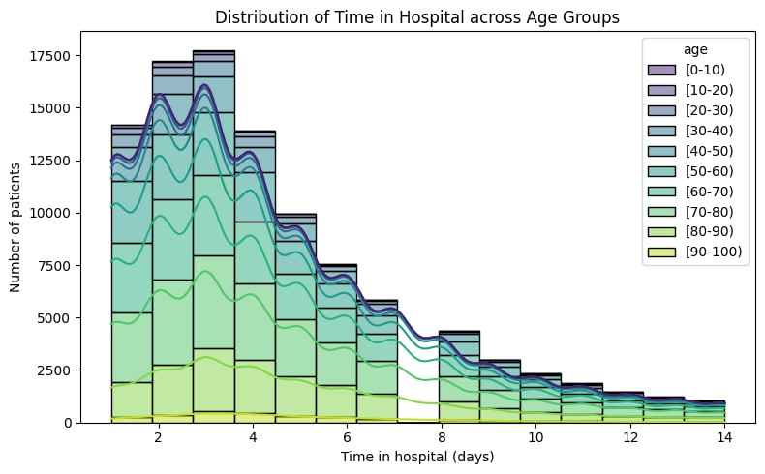
Across all age groups, the overall shape of the distribution remains similar, indicating comparable hospitalization dynamics. However, a slight rightward shift is observed for older age categories, suggesting a tendency toward longer hospital stays among elderly patients. This pattern reflects increased clinical complexity and a higher prevalence of comorbidities in older populations.
The majority of patients in all age groups are concentrated within the up to 6 days hospitalization range. Nevertheless, the proportion of extended hospital stays increases with age, highlighting a growing likelihood of prolonged treatment among older patients.
Overall, despite observable differences between age groups, changes in hospitalization duration occur gradually rather than abruptly. This indicates that age has a moderate and systematic influence on the length of hospital stay, rather than acting as a dominant determinant.

3.5 Insights
Multiple visualization techniques were employed to complement statistical summaries. Histograms were used to examine feature distributions, scatter plots to explore relationships between key variables, and heatmaps to visualize correlation structures. These visual tools facilitated intuitive interpretation of complex data patterns.

EDA results indicate that patients with longer hospital stays, higher treatment intensity, and repeated prior hospitalizations exhibit an elevated risk of readmission. In contrast, purely demographic variables demonstrate a comparatively weaker predictive influence. These insights informed the selection of features and modeling strategies.

4 Data Mining Techniques

4.1 Algorithms
To solve the classification task, four different machine learning algorithms were implemented and compared:
- Logistic Regression
Used as a baseline model due to its simplicity, interpretability, and robustness.
- Random Forest Classifier
An ensemble method capable of capturing nonlinear relationships and feature interactions.
- K-Nearest Neighbors (KNN)
A distance-based algorithm that classifies observations based on similarity to neighboring points.
- Decision Tree
A rule-based model that provides high interpretability but is prone to overfitting.
The selected algorithms represent a balance between interpretability and modeling complexity. Logistic Regression serves as an interpretable baseline model, while Random Forest captures non-linear relationships and feature interactions. KNN and Decision Tree provide complementary perspectives on instance-based and rule-based classification, respectively.

4.2 Model Evaluation & Comparison
Given the imbalanced nature of the target variable, model performance was evaluated using multiple complementary metrics, including accuracy, precision, recall, F1-score, and area under the ROC and Precision–Recall curves. Particular emphasis was placed on recall, as failing to identify high-risk patients may have significant clinical consequences.
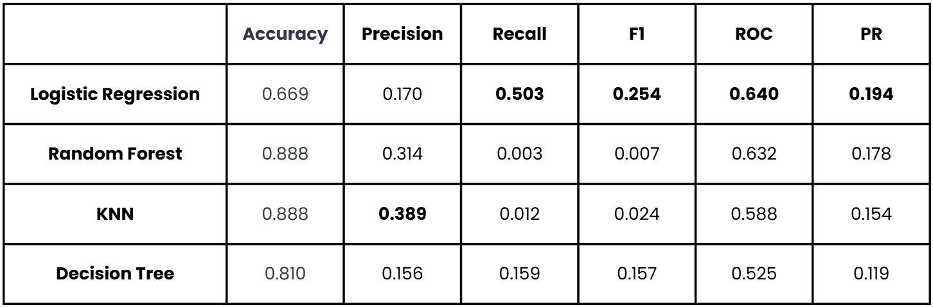
The results indicate that Logistic Regression achieves the highest recall, making it the most effective model for identifying patients at risk of readmission. This is particularly important in a clinical context, where failing to detect high-risk patients (false negatives) may have significant consequences. In contrast, Random Forest and KNN demonstrate high accuracy but extremely low recall, indicating a strong bias toward the majority class and limited ability to detect readmission cases.
Overall, the comparison highlights the trade-off between accuracy and sensitivity and supports the selection of Logistic Regression as the most clinically appropriate model for this task.

4.3 Cross-Validation Strategy
To obtain reliable and unbiased estimates of model performance, a GroupKFold cross-validation approach with five folds was employed. This strategy was selected to explicitly address the structure of the dataset, in which multiple hospital encounters may correspond to the same patient.
Key characteristics of this approach:
- splitting was performed based on patient identifiers,
- no patient appeared in both training and validation sets within any fold.
This design effectively prevents data leakage and leads to more realistic performance estimates, which is particularly important in healthcare applications where patient-level generalization is required.
This strategy:
- prevents data leakage between train and test sets,
- ensures patient-level independence,
- provides more realistic estimates of model performance in a medical context.
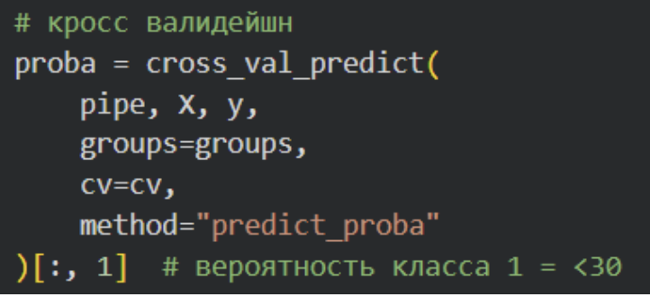

Cross-validation was applied consistently across all evaluated models, allowing for a fair comparison of algorithm performance under identical data partitioning conditions. The use of multiple folds further reduces variance in the evaluation results and increases confidence in the robustness of the obtained metrics.

4.4 Hyperparameter Tuning
Hyperparameter optimization was conducted to improve model performance and assess the sensitivity of algorithms to parameter selection. For Logistic Regression, both GridSearchCV and RandomizedSearchCV were applied to explore different configurations of regularization strength and solver parameters.
Two approaches were used:
- GridSearchCV — exhaustive search over a predefined parameter grid,
- RandomizedSearchCV — random sampling from a wider parameter space.
GridSearchCV enabled an exhaustive search over a predefined parameter space, ensuring systematic evaluation of key hyperparameters. In contrast, RandomizedSearchCV allowed a broader exploration of the parameter space with reduced computational cost. Both approaches were evaluated using the same GroupKFold cross-validation scheme to maintain consistency.
After tuning, small but consistent improvements were observed in ROC-AUC and Precision-Recall AUC, indicating improved discrimination capability without overfitting.

5 Results

5.1 Evaluation Metrics and Model Performance
Model performance was evaluated using a set of complementary classification metrics, including:
- accuracy,
- precision,
- recall,
- F1-score,
- ROC-AUC,
- Precision–Recall AUC.
Given the imbalanced nature of the target variable, metrics focused on the minority class—particularly recall and Precision–Recall AUC—were considered more informative than accuracy alone.
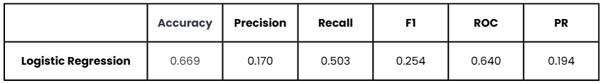
The main results for all evaluated models are summarized in Table X. While Random Forest and KNN achieved the highest accuracy values, these models exhibited extremely low recall, indicating poor performance in identifying patients who were readmitted within 30 days. In contrast, Logistic Regression demonstrated substantially higher recall and more balanced overall performance across metrics.

5.2 Baseline vs Improved Models
Logistic Regression was used as the baseline model. Hyperparameter tuning was performed using GridSearchCV and RandomizedSearchCV to assess whether performance improvements could be achieved through parameter optimization.
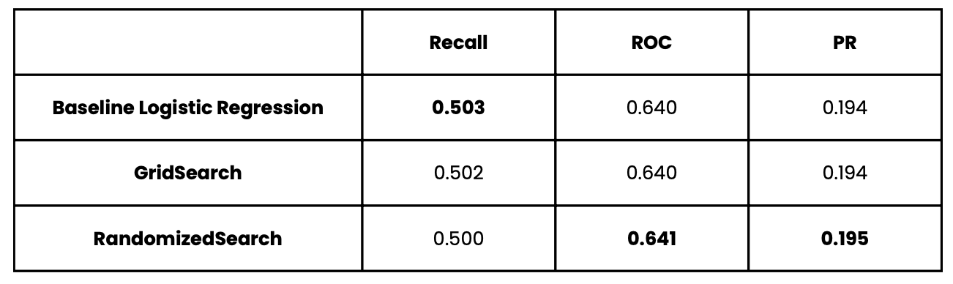
Comparison of baseline Logistic Regression with tuned versions showed:
- stable Recall around 0.50,
- slight improvement in ROC-AUC after RandomizedSearch,
- consistent performance across cross-validation folds.
The comparison between the baseline and tuned models indicates that performance gains were marginal. Recall values remained stable across all configurations, while small improvements were observed in ROC-AUC and Precision–Recall AUC for the tuned models. These results suggest that the baseline model was already near an optimal configuration and that model performance is primarily constrained by dataset characteristics rather than hyperparameter selection.

5.3 Model Performance Visualization
Model evaluation was further supported by visualizations:
- Confusion Matrix, illustrating the distribution of true and false predictions,
- ROC curves, comparing the discriminative ability of all models.

To further analyze model performance at the individual prediction level, a confusion matrix was constructed for the selected classification model. The confusion matrix provides a detailed breakdown of prediction outcomes by comparing true class labels with model predictions, allowing for the assessment of true positives, false positives, true negatives, and false negatives. In the context of hospital readmission prediction, particular attention is given to false negatives, as failing to identify high-risk patients may have serious clinical implications.
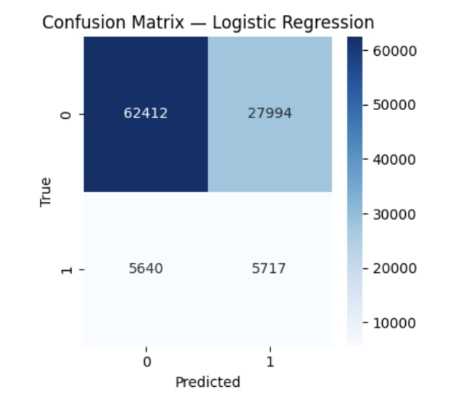
The matrix shows how the model classifies two classes:
- 0 - the patient will NOT be readmitted within 30 days
- 1 - the patient WILL be readmitted (<30)

Divides predictions into 4 categories:
- TP — confidently identifies cases without risk of
- readmission
- FP — incorrectly counted the patient
- FN — missed readmission cases (critical error type)
- TN — correctly identified a missing readmission

In medicine, minimizing FN is especially important. Shows the model's error balance and the quality of rare class detection.

In addition to threshold-dependent metrics, Receiver Operating Characteristic (ROC) curves were used to evaluate the discriminative ability of the models across different classification thresholds. ROC curves illustrate the trade-off between the true positive rate and the false positive rate, providing a comprehensive view of model performance independent of a specific decision threshold. The area under the ROC curve (ROC-AUC) serves as a summary measure of how well a model can distinguish between readmitted and non-readmitted patients.

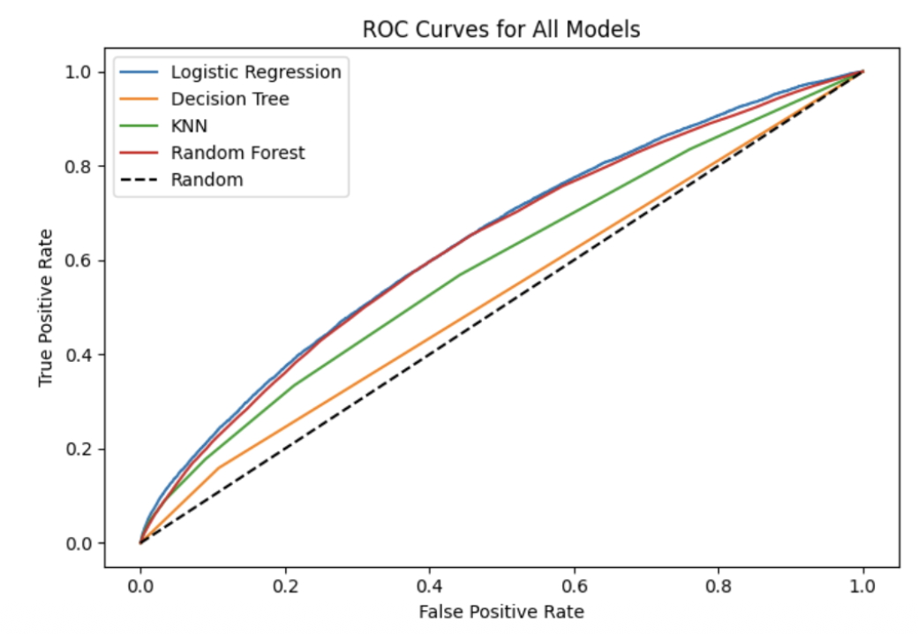

ROC curve analysis demonstrates that Logistic Regression achieves the highest discriminative ability among the evaluated models. Precision–Recall curves further confirm its advantage under class imbalance conditions, showing more stable performance in identifying high-risk patients compared to tree-based and distance-based models.

5.4 Hypothesis check
Hypothesis 1 (H1): Demographic and Clinical Factors
The analysis shows that clinical characteristics are more strongly associated with hospital readmission risk than demographic variables. In particular, length of hospital stay, number of prescribed medications, and history of hospital visits demonstrate a noticeable relationship with readmission within 30 days. In contrast, demographic factors such as age and gender exhibit a comparatively weaker association. Therefore, Hypothesis 1 is partially supported.
Hypothesis 2 (H2): Hospital Stay Duration and Treatment Intensity
The results clearly indicate that both the duration of hospitalization and treatment intensity are positively associated with readmission risk. Patients with longer hospital stays and a higher number of medications and laboratory procedures show an increased likelihood of early readmission. These findings provide strong empirical support for Hypothesis 2.

Hypothesis 3 (H3): Predictive Model Feasibility
The results confirm that predictive modeling of hospital readmission is feasible using the available dataset. Multiple classification algorithms were successfully trained and evaluated. Among them, Logistic Regression demonstrated the most balanced performance, particularly in terms of recall and discriminative ability, despite overall performance limitations related to class imbalance. Thus, Hypothesis 3 is confirmed.

6 Conclusion

6.1 Advantages and Disadvantages of the Algorithms
Logistic Regression
- Advantage: High interpretability, best Recall performance
- Disadvantage: Limited ability to model nonlinear patterns
Random Forest
- Advantage: High overall accuracy
- Disadvantage: Extremely poor Recall for the minority class
KNN
- Advantage: High Precision
- Disadvantage: Poor scalability and sensitivity to feature dimensionality
Decision Tree
- Advantage: Simple and interpretable
- Disadvantage: Prone to overfitting

6.2 Model Justification
Logistic Regression was selected as the final model because minimizing false negatives is critical in healthcare applications, where failing to identify high-risk patients may lead to serious clinical consequences. In addition, the model provides stable and interpretable results, allowing for transparent assessment of the contribution of individual features. Overall, Logistic Regression achieves the most appropriate balance between sensitivity and overall performance among the evaluated models, making it the most suitable choice for this task.

6.3 Future Work
Future improvements may focus on extending the current approach in order to enhance predictive performance and improve clinical applicability. The following directions represent promising avenues for further development:
• applying class imbalance techniques such as SMOTE,
• experimenting with gradient boosting models (XGBoost, LightGBM),
• optimizing classification thresholds based on clinical priorities,
• incorporating temporal patterns between multiple hospital admissions.
Collectively, these improvements could address key limitations of the current study, particularly those related to class imbalance, model flexibility, and the static nature of the available features. Implementing these approaches may lead to more accurate identification of high-risk patients, improved alignment of model outputs with clinical decision-making processes, and stronger generalizability of the proposed solution in real-world healthcare settings.

